EXECUTE AND TEST YOUR MODEL

|  |  |
| --- | --- |
| **Team ID** | **PNT2022TMID42057** |
| **Project Name** | **Car Resale value Prediction** |

EXECUTE AND TEST YOUR MODEL

App.py

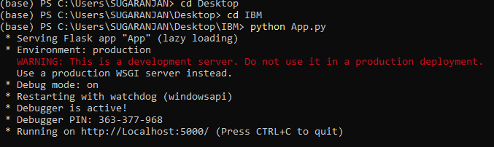

Index.html

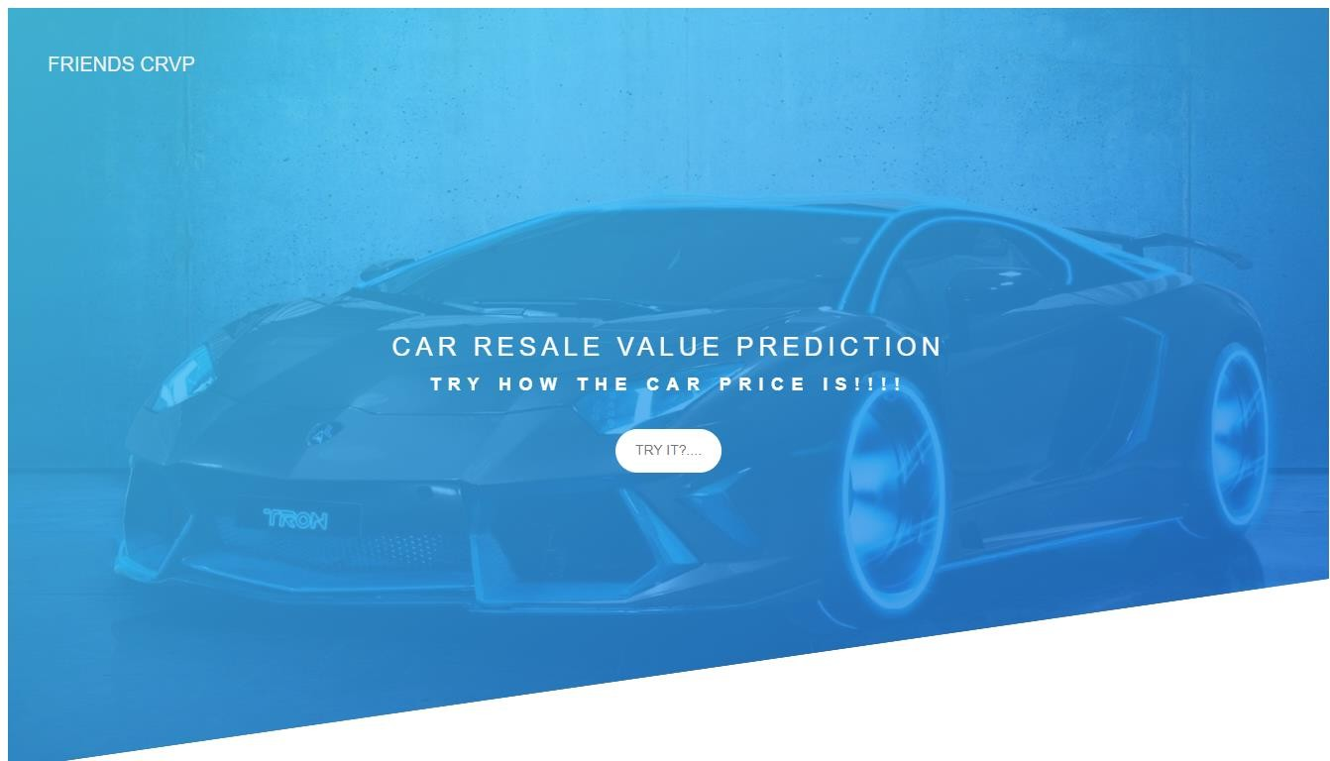

resaleintro.html

